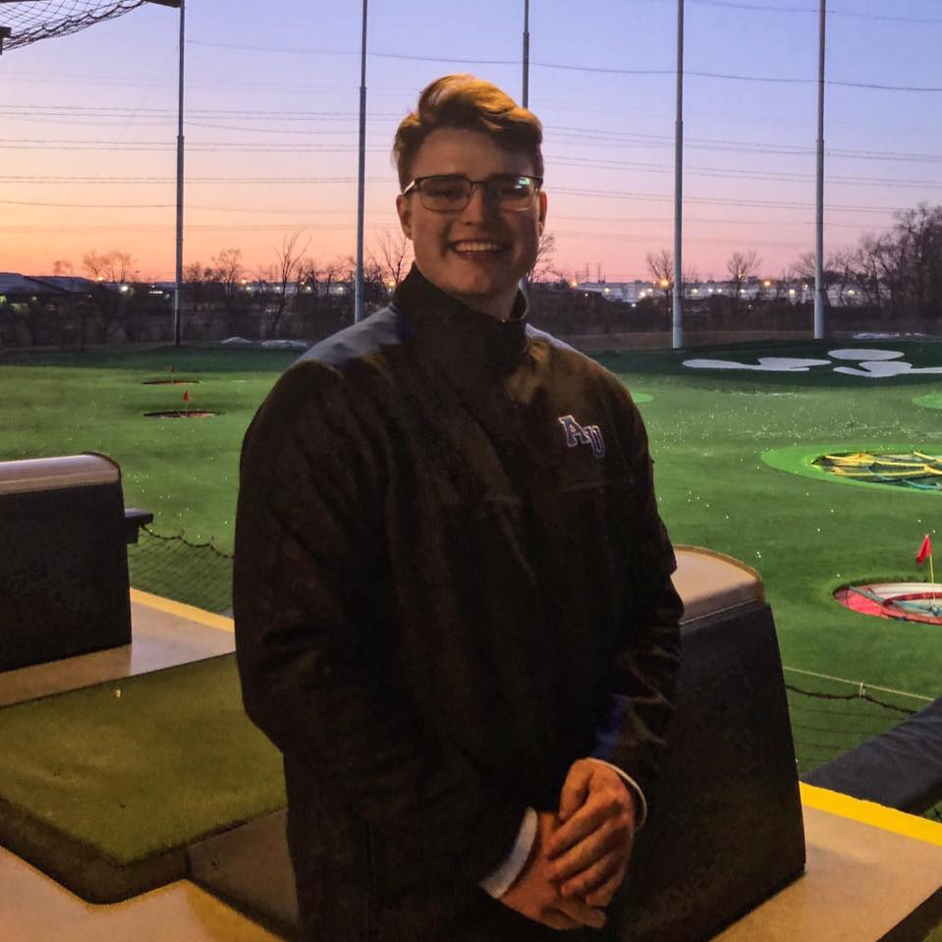Hello back! My name is Matthew Ayers, and I am a Computer Science major. I just go by he/him and am a transfer student from Illinois Central College. After spending 2 years there, I am now in my second year at AU, during my first year I completed a minor in Mathematics. To be completely honest, I am in CSC 4500 partly because I am required to be in it, but also because I am curious what it is. I am not in any organizations through AU but as I continue to work towards the goal of graduation, I am intensely looking for a job since I do intend to stay up near Naperville.

This adventure is about 2 and a half hours away from my hometown, Washington IL where my mother still lives, and I chose this college partly because of my girlfriend of almost 3 years. We intend to move in together after I finish college, which excites me so, but I will need a job of course to do that

My main hobbies are video games and watching random videos on YouTube and Twitch. I even have a very small community myself on Twitch, after starting just a few months ago. I play a little bit of everything on my PC, but my favorites are Magic The Gathering (card game I also play in real life), SMITE, and Rocket League. Being a competitive player as myself, I play A LOT, which is how I’ve gotten to a level where I can now play professionals in Rocket League. I only say this because it pretty much helps my Twitch! Other than games, I grew up playing basketball and baseball. When I got to high school, I also played football, which was the only sport I kept playing after sophomore year. I could go on and on for the reasons I quit the other two, but simply enough, the football coaches were the best I ever had, it felt like a family that I never had.

As of now, I do not have any pets sadly and I haven’t had one in a few years due to moving around with my mother. I have been living my pet life vicariously through my girlfriend and her two labs, never was a lab guy but they are adorable. As soon as I get a place, I intend to look for a big floofer. I really want a cinnamon Chow so I can name her or him Toast!

My first choice wasn’t even computer science surprisingly since all I do is play games or watch screens. Some of my passions are Chiropractors and Marine Biologist. Funny enough both of those two professions require a TON of Science. What’s not funny is I am terrible at science, the highest grade I’ve ever gotten was a C and that was Physics where math saved me. So instead, I went the route that I’ve been led on since sophomore year of high school.

I intend to learn all that I can from this course! As my senior year, I want it to be the best that it can!